DEALS TO BEAVERTON

You’ll be surprised just how perfectly Beaverton’s small-town charm is seamlessly combined with Portland’s first-class scene. Known for its many attractive and well-planned neighborhoods, there’s plenty to see in Beaverton. Book a trip to Beaverton via Portland International Airport on Virgin America. Live it up at 35,000 feet with WiFi, on-demand entertainment, and more on every flight.

(MARKET IMAGE HERE)

Find Deals From These Cities

INSERT FARE GRID FROM / TO Version (if available!)

   
Top Things To Do in Beaverton

If you’re looking for things to do in Beaverton, Oregon, below are a few highly recommended things to check out when you’re visiting this city.

* Spend a day at the Beaverton Farmers Market, Oregon’s largest all-agricultural market. From nursery growers and ranchers, to farmers and artisan food producers, there’s a wonderful array of vendors to shop from. The market also offers live music every week and is nearby to the Beaverton Library and City Park – the perfect place to take your newly purchased foods and have a picnic.
* Explore the Tualatin Hills Park and Recreation District, one of the most popular activities in Beaverton. With more than 60 miles of hard- and soft-paved trails and over 90 park sites, you’ll love getting an up-close look at the streams, forests, birds, and other wildlife throughout the district.
* Enjoy a performance at the award-winning Beaverton Civic Theatre. With more than 200 volunteers working hard to provide quality theatrical experiences for the community, you’re sure to appreciate and enjoy any performance.
* The Portland area is home to a fantastic microbrew scene. Check out the Golden Valley Brewery or Red Ox Brewing for some local flavor.
* Beaverton is home to Nike Headquarters. While the campus is closed to the public, you can take a jog around the Westside Trail and feel the athletic spirit.

Travel Tips and Resources

[Must-Dos in Beaverton](http://www.movoto.com/guide/beaverton-or/things-to-do-in-beaverton)

[Beaverton Hotels](http://www.tripadvisor.com/Hotels-g51765-Beaverton_Oregon-Hotels.html)

[Beaverton Restaurants](http://www.tripadvisor.com/Restaurants-g51765-Cocoa_Beaverton_Oregon.html)

[Beaverton Shopping Guide](http://beavertontownsquare.com)

[Beaverton Nightlife and Entertainment](https://roadtrippers.com/us/beaverton-or/activities-nightlife-and-party-beaverton-7631?lat=40.80972&lng=-96.67528&z=5)

[Beaverton Travel Tips](http://www.beavertonoregon.gov/index.aspx?nid=99)

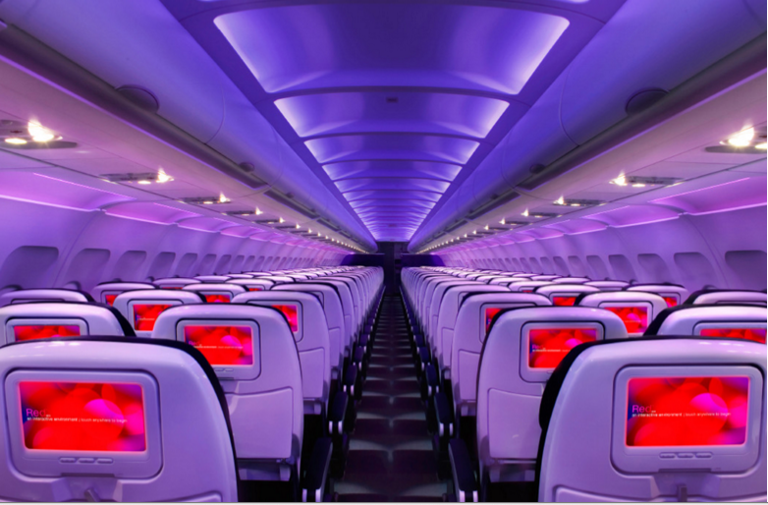

Main Cabin Main Cabin Select First Class

(add links to Cabin Class Pages)

Ready. Set. Fly.

Book your Mood-lit Ride to Beaverton

When traveling to Beaverton, book a flight with Virgin America to Portland International Airport. Located just seven miles from Portland, you’ll be in Beaverton in no time. Fly with us and enjoy our comfortable leather seats, relaxing mood-lit cabins, as well as a variety of on-demand entertainment options. Take a virtual tour to learn more about our terrific amenities.

Take a Virtual Tour

Add Terms & Conditions